Why We Use Common Paper

Standard Agreements

Why do we use this agreement?
We use a Common Paper standard agreement as our form template because it is an open standard that reflects industry standard and reasonable terms for both sides. These standard agreements are created by a neutral third party so you can trust there are no hidden clauses for the benefit of one side. Using a standard agreement allows us to start in the middle and focus on what really matters: working together.

Why should you trust this agreement?
Common Paper standard agreements are created by a committee of over 3 dozen practicing attorneys. Their backgrounds range from in-house counsel for technology vendors and procurement teams, to outside counsel from boutique firms and Big Law. The Common Paper Committee designed these standard agreements to be fair without heavily favoring either side.

How do you use this agreement?
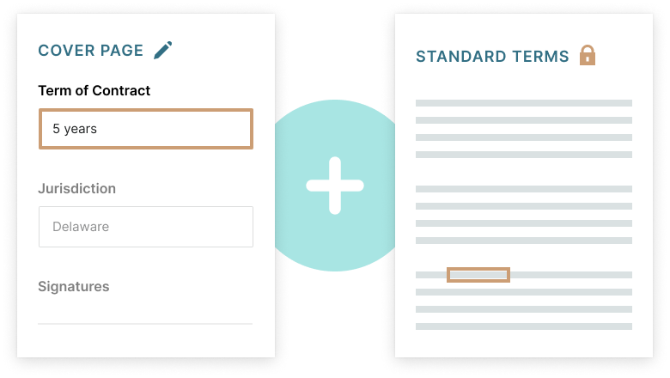
You’ll receive a Cover Page with the specific details of our deal. Any modifications to the Standard Terms should be made on the Cover Page. Incorporating the Standard Terms by reference from the Common Paper website gives both sides assurance that all modifications are explicitly called out in the Cover Page. Once you review the details and accept, you’ll receive a signature request from Common Paper.

Who is Common Paper?
Common Paper is an independent company developing open standards for commercial contracting. They make their standard agreements available to the public and free for anyone to use under the Creative Commons (Attribution 4.0) license terms.

